Pine WaveNow Electrochemistry

Connect electrodes to the aligator clips coming from WaveNow instrument.
Red: Working Electrode (Au, Pt, or C disk).
Green: Auxiliary Electrode (Platinum wire or graphite rod).
White: Reference Electrode (Ag/AgCl).
The orange lead should be plugged into the red banana plug.
Run the AfterMath software.  Connect the WaveNow Potentiostat to your computer using a USB cable.  Connect the power cord, turn on the potentiostat, wait for the potentiostat to appear in the AfterMath Instrument List, and select Pine WaveNow (0).  Create an empty archive to store your data (1).  Choose the desired method, usually “Cyclic Voltammetry” (2), from the Perform an experiment list or from the Experiments menu. For cyclic voltammetry set three segments, the initial, upper, lower, and final volts (make the final equal to the initial), direction (falling = reduction or rising = oxidation) and sweep rate (100 mV/sec). | 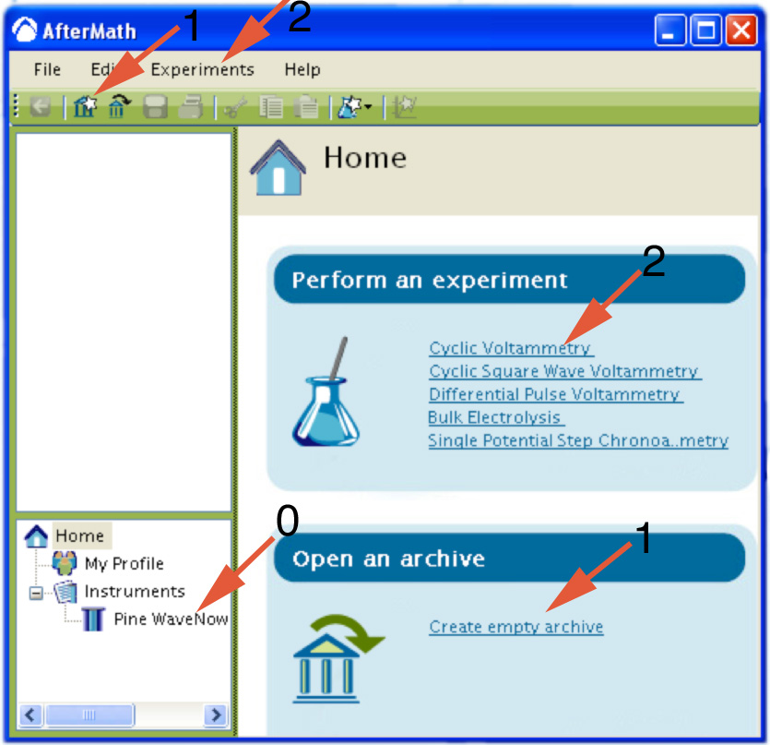
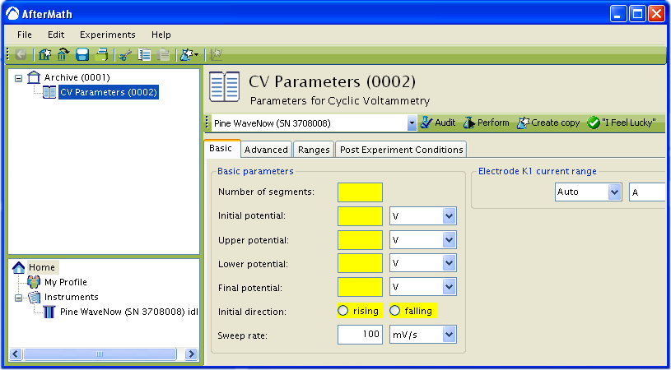
Click on the perform button. (If the button is gray, make sure that the basic parameters are filled in and that an instrument has been selected.) The results of the experiment are placed in the archive.
To overlay spectra, copy-and-paste a trace from the file list under “voltammogram” or control-drag the words “current vs potential” from the file list onto another plot.
The peak position for a cyclic voltammogram can be obtained by right-clicking on the trace and selecting Add Tool » Crosshair. Drag the crosshair to the peak. In cyclic voltammetry remember to label both the oxidation and reduction peaks for each trace.
The peak current for a cyclic voltammogram can be obtained by right-clicking on the trace and selecting Add Tool » Peak Height. This places a peak measurement tool on the voltammogram. You can move the position of the peak tool and adjust the baseline using the control points on the tool.
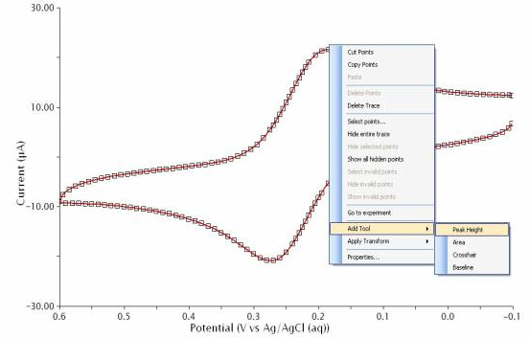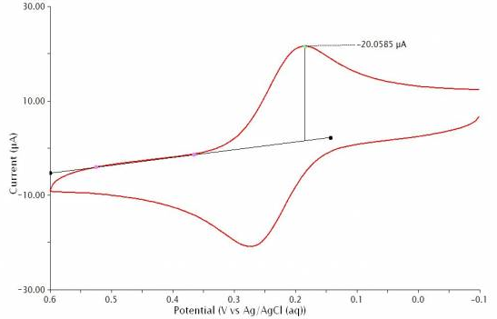
At the top of every plot there is a toolbar. The first three tools on the left side of this toolbar may be used to select entire curves (traces), portions of traces, or individual points.
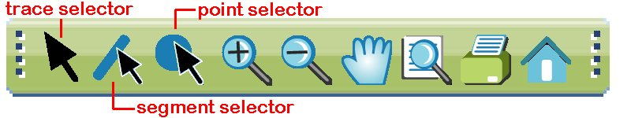
To label a point, use the point selector tool to right click on the point. A “Point Properties” dialog will appear. Click the x or y selection box to display that value.
References
WaveNow Users Manual at
https://www.pineresearch.com/shop/knowledgebase/pine-aftermath-user/
Variables in Cyclic Voltammetry at http://chemistry.beloit.edu/classes/Chem220/cyclic

